**camera driver install instruction**

Step 1: Put the CD into the computer CD-ROM, after the computer has read the CD, you will find there are two folders named “Driver” and “Software” in the CD like this picture shows:

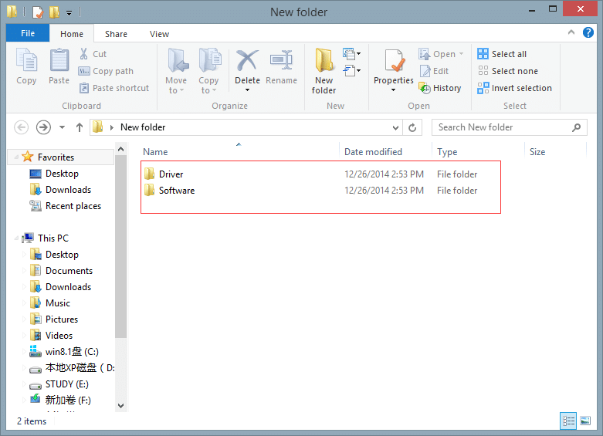

Step 2: Connect the device to computer via the USB cable, turn on the device. If your system is window8, it will automatically install the device. Like this follow picture shows. The installation will take a moment, after the successful installation of the device, click “Close”.

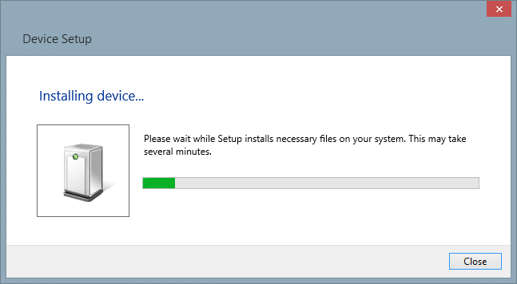

Step 3: Right click “This PC”, choose “manage” to enter the computer management platform, please refer to this follow picture.

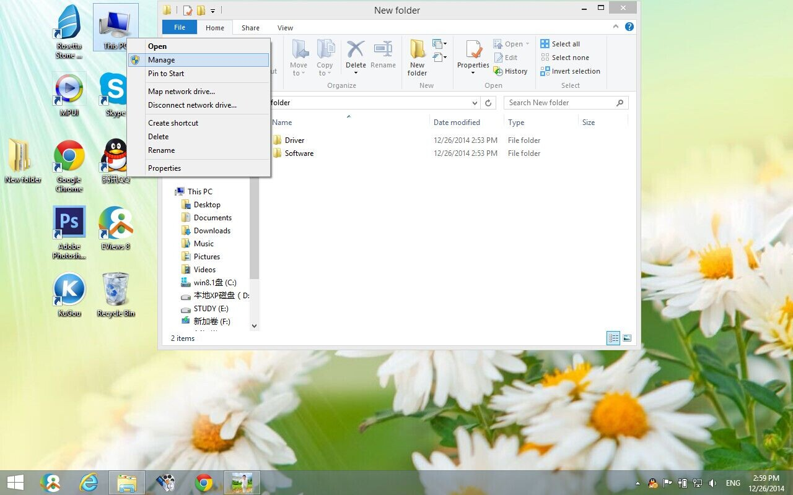

Step 4: After entering the computer management platform, find the “Device Manager” item in the “System Tools” list. Double click to open it. Refer to this picture below.

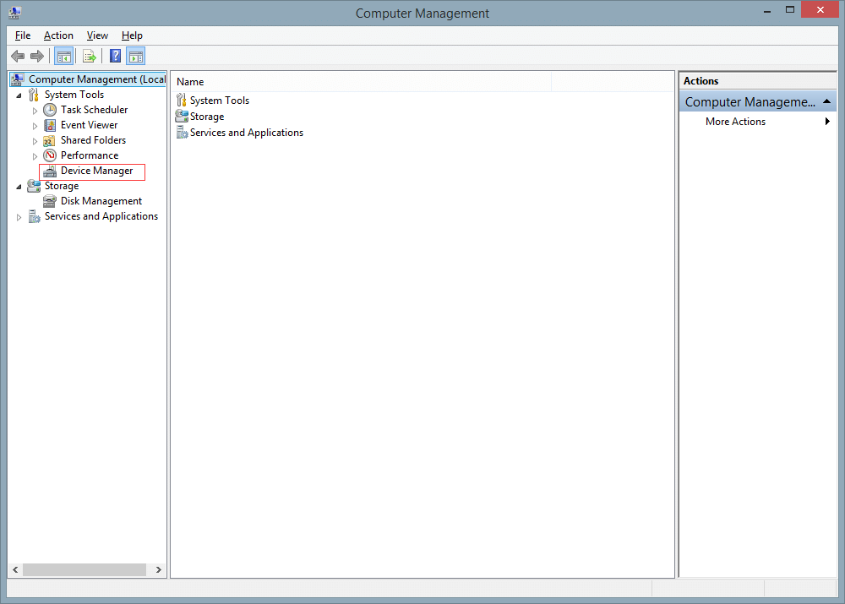

Step 5: Find the “Other devices” item in the “Device Manager” unfolding list. Click the “Other devices” item, you will find there will be a “Amba Simple Class” item marked with a exclamation mark. Refer to this picture below.

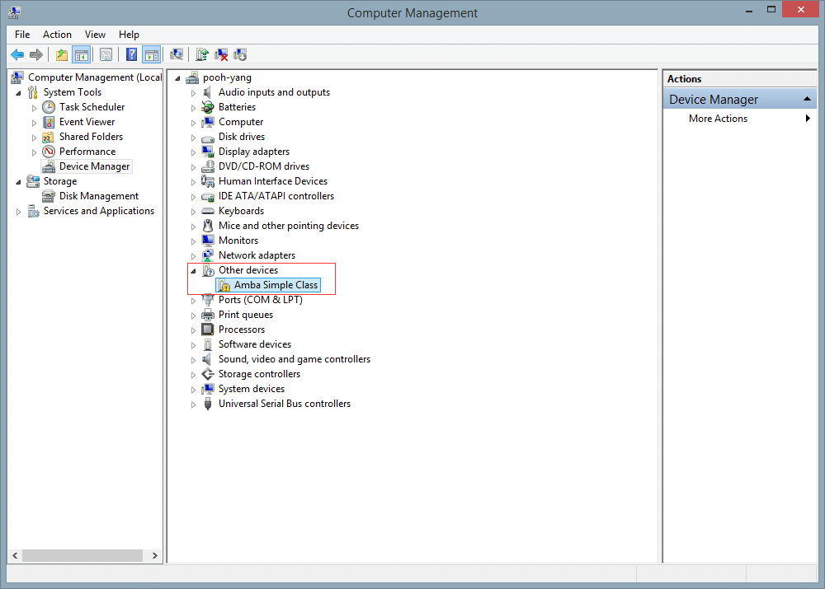

Step 6: Right click the “Amba Simple Class”, choose the “Update Driver Software…” , click. Refer to this picture below.

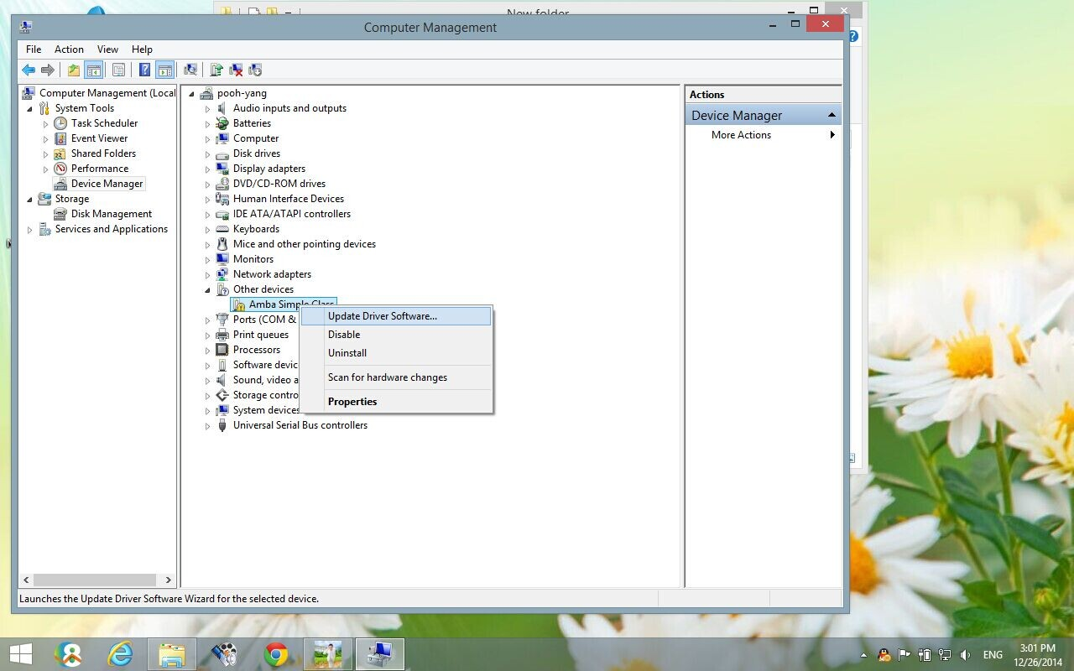

Step7: Update the driver software by clicking the second one “Browse my computer for driver software”. Refer to this picture below.

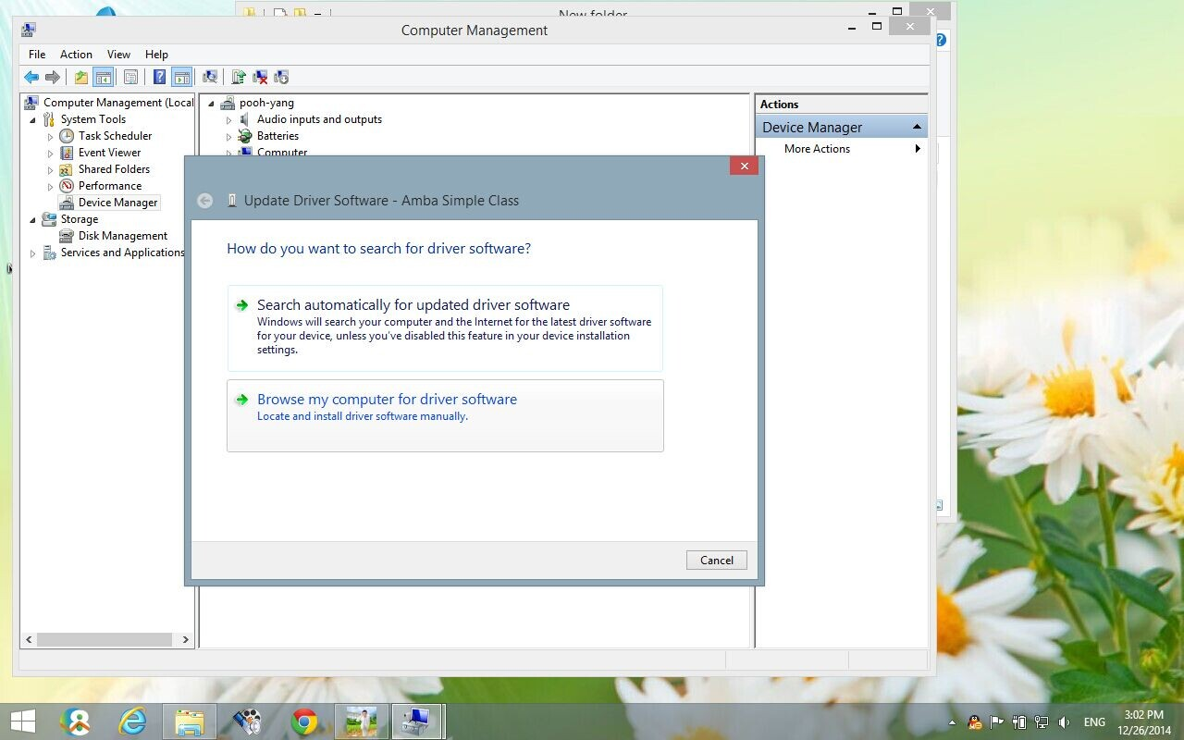

Step 8: Find the CD folder named “USB SOFTWARE”, click the “Driver” folder to unfold, and find the other “Driver” folder in it, select it and click “OK”. Refer to the pictures below.

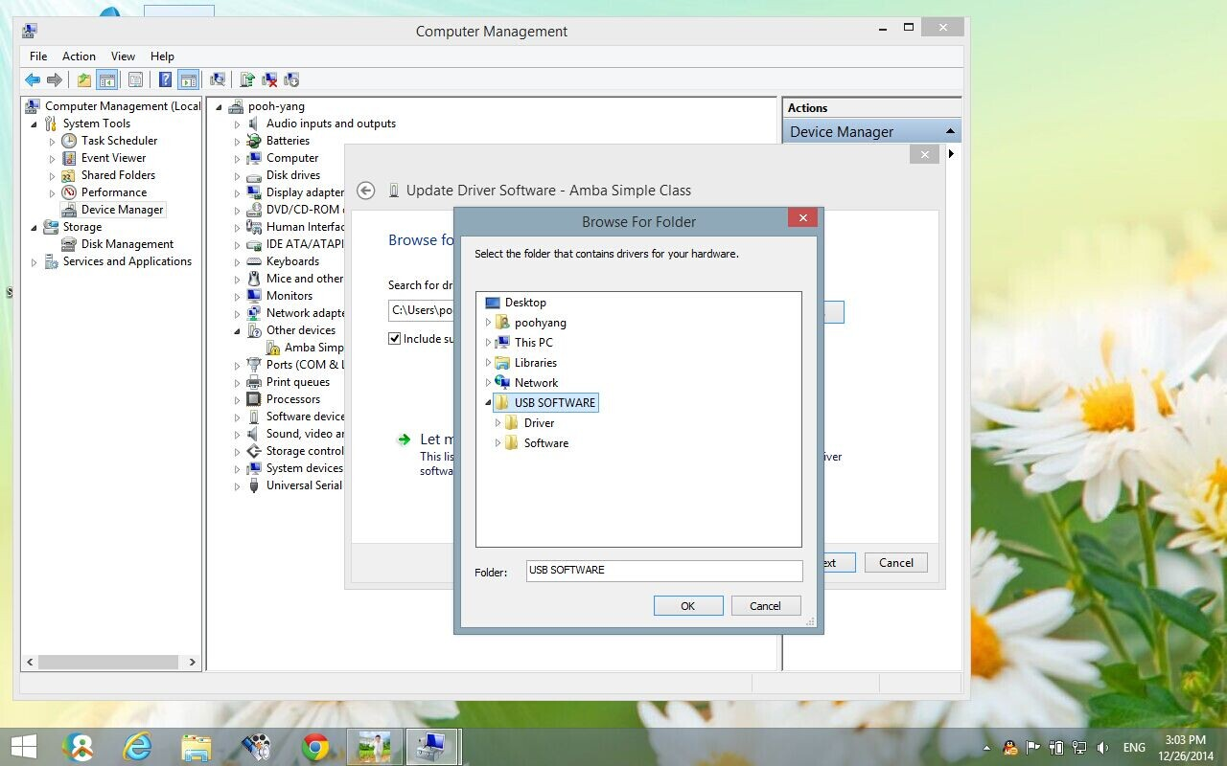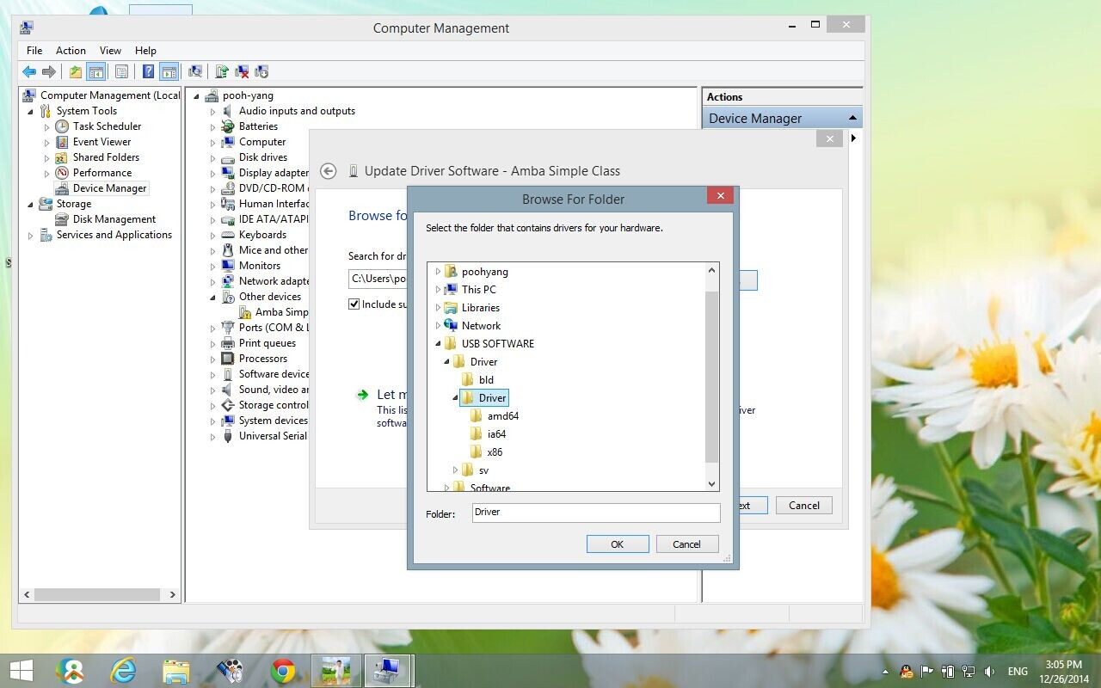

Step 9: Click “Next”, the computer will begin to search the software and install. It may take a moment. Refer to the pictures below.

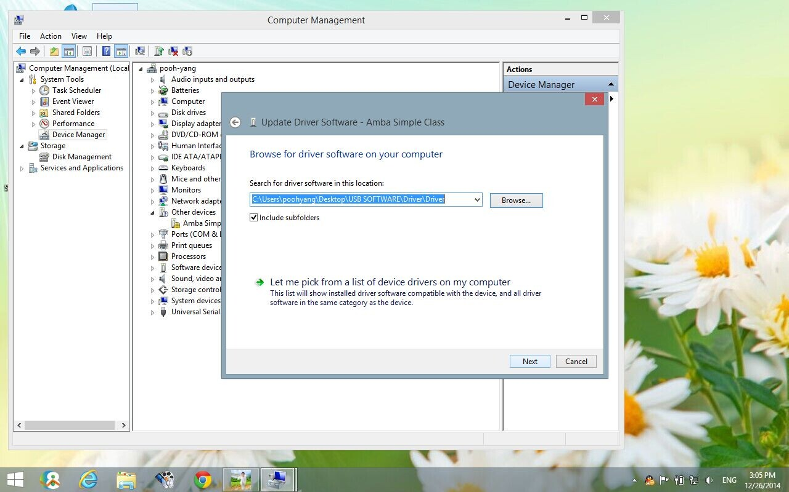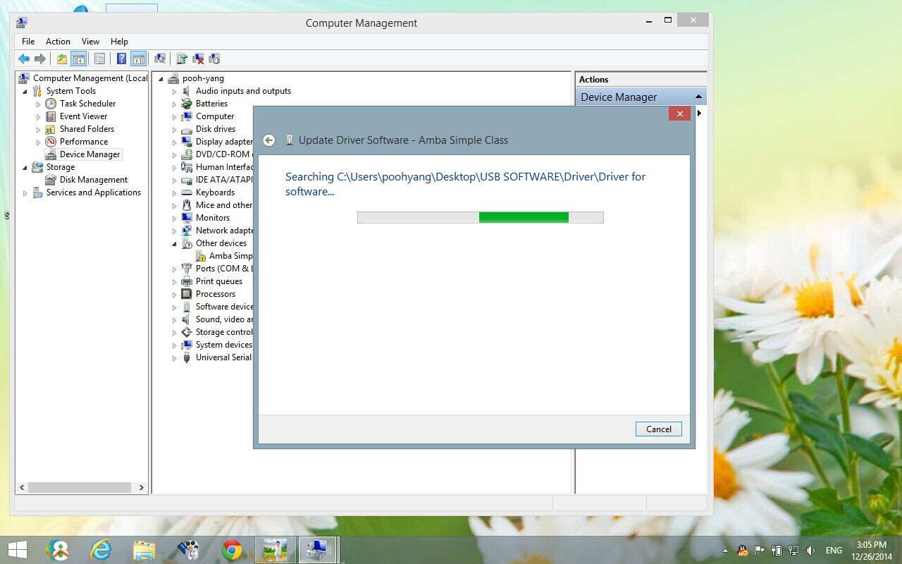

Step 10: Your computer may have installed some kind of antivirus software. So it may remind you of this.

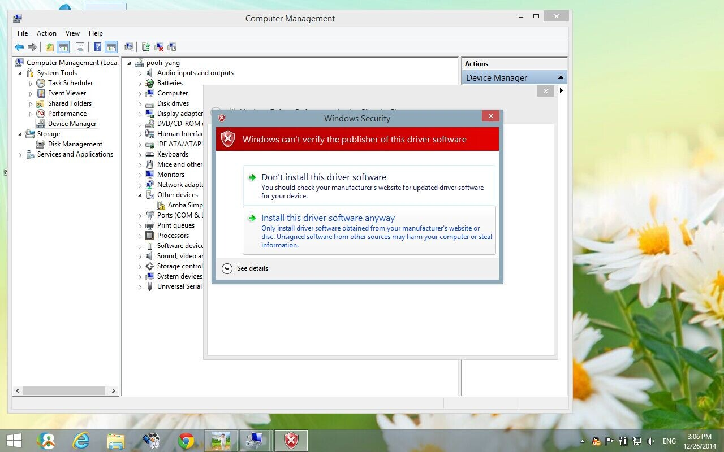

Choose the second one “Install this driver software anyway”, then after the installation of the updated driver software. Click “Close”. Refer to this picture below.

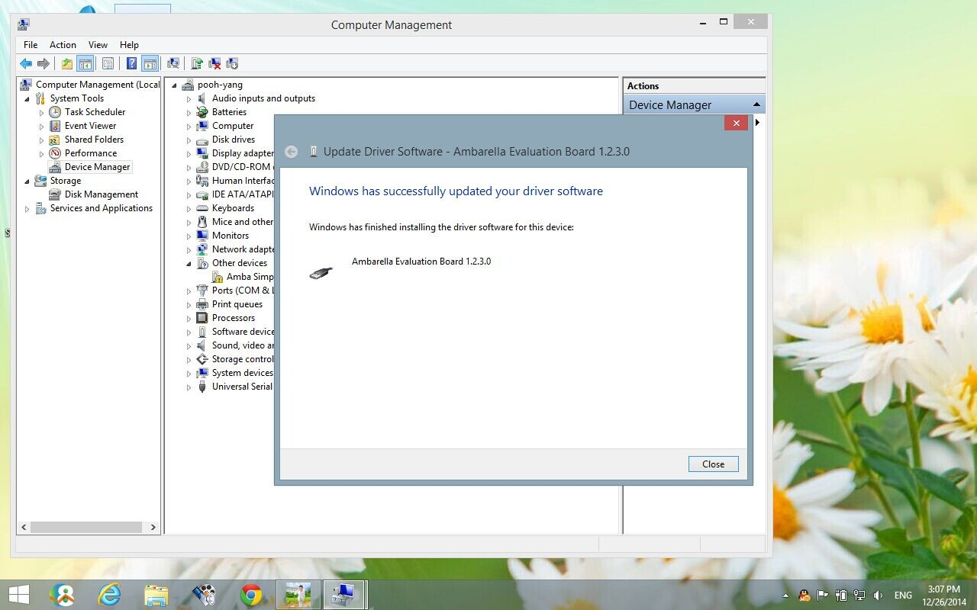

Step 11: Go back to step 5 screen, you will find there will be a “Ambarella Evaluation Board” item marked no exclamation mark which means that the driver has been installed successfully. Refer to this picture below.

